Outline Stewardship Guide for Lightwave Groups and Hubs

This short guide introduces what is hoped are some helpful principles and resources to develop generous giving from Lightwave Hub congregations and Lightwave group members. This will form an essential part of an overall sustainability plan for hubs and groups as funding from the Growing in God in the Countryside (particularly for ministry posts) comes to end from the end of 2024 (some posts are funded for a little longer).

Generosity is at the heart of our faith, we believe in a generous God and our own generosity is a testament and hallmark of our faith in action. Although we are looking at other sources of income the ministry and mission of Lightwave will need to be largely funded through the incredible generosity of those who give to it.

Discipleship and Giving Principles

MINT – Enabling Giving

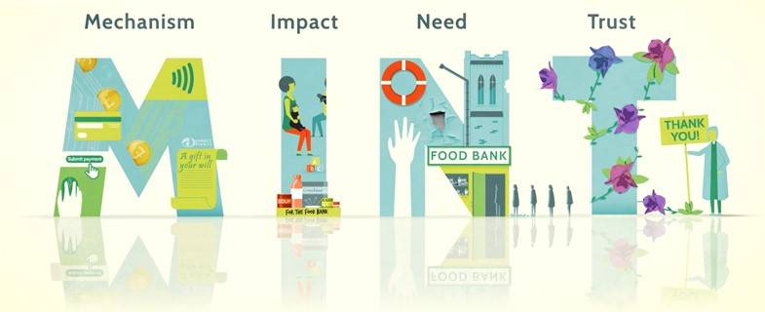

To encourage and increase giving from individuals there are four areas we need to focus on, and they helpfully form the acronym MINT. If you have these things in place, you have created the best environment for people to give. There is more detail at this link here.

The central Lightwave team are providing customisable leaflet templates in CANVA which seek to embody these principles and can also be used for local websites. There are also general resources linked from the main Giving page on the Lightwave Community website and there will be links there to a webpage for each hub and any groups that need them. Just contact Andrew Gosden or Becky Luetchford. Becky can also help you set-up a free Canva account if you don’t already have one and has made you a helpful video on how to use it. If you need more help please ask Becky.

- Mechanism – Have the right mechanisms for giving, such as direct debit, contactless, online, legacies, gift aid and so on. Make it easy. The leaflet templates will contain links and QR codes for one-off and regular giving including gift aid. They will also contain a paper form as an insert if people prefer that. Other resources will be downloadable from the main Giving page on the Lightwave Community website

- Impact recording – Show the impact of people’s giving, how it enables the church’s ministry and mission. Talk about the difference you are making and what we are doing. Videos are great for this, and Becky can help you here. The central team are also developing simple practices for monitoring and evaluating the impact of the work you do and how you are meeting wider strategic aims. This doesn’t have to be onerous or complicated and is also essential for reporting to any external funders.

- Need – Explain the need for people to give, so they see how important it is that they give. Talk about the compelling need, explain what we need now, but also what we need in the future as project funding stops. Explain we are only paying for a small proportion now. Andrew can help you understand that for your own situation and produce any financial graphics you might need. NOTE: It is really important to encourage regular giving from as many people as possible even if it is a small amount. It could be as little as the price of a coffee a week or even a month. This is about establishing patterns so giving can increase, and encouraging an ALL INVOLVED approach where people give as well as receive.

- Trust – Build trust, so that people have confidence that the hub or group will spend gifts wisely and well. Make sure there is transparency on what its spent on. Explain it’s being used wisely and well. Have someone who can organise thanking people regularly (at least annually) for their giving. Andrew can help you here with details of who gives and how much – but keep that information confidential to literally one or two (and probably NOT the church/hub/group leader).

If you have these things in place, you have created the best environment for people to give. You can find more on all these areas from the national church giving team on the Church of England website, including advice, guidance, training and case studies (you will need to re-interpret them slightly for our context)

Understandably, many people focus on the ‘mechanisms’ section, as this shows how to provide the different ways people wish to give. However, please don’t neglect the other areas, they are every bit as important and you need to give them equal attention. There is a multiplier effect with these four areas, the more you develop one area, the greater the impact of the work you do in the other areas. Don’t forget too that this is all a team endeavour, it is important that we all take a responsibility for enabling giving and we all work together to enable giving.

The national Church of England giving team run regular webinars on developing our effectiveness in these areas too, and you will always be welcome to join them and find out more. Again, you will just need to interpret them for your own context.

IDEA (Encouraging Generosity)

We believe in a generous God, who longs for us to share his generosity with others. A generous life is therefore a hallmark of our faith and a testament to it, as the more generous we are, the more we reflect the generous God we believe in.

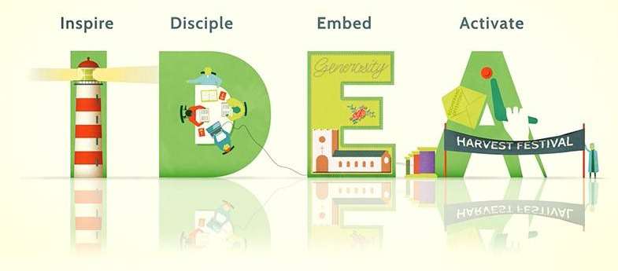

A generous culture is also essential for a church to develop a sustainable ministry. That generosity can be expressed in many different ways. It is not only about financial giving, but then financial giving is part of living generously. To cultivate a generous culture, there are four areas we need to focus on:

- Inspire people through generous leadership and celebrating generosity within the life of the hub or group
- Disciple hub and group members, through resources, teaching and learning, so people can grow in an understanding of God’s generosity towards them, and how they can live generous lives.
- Embed generosity in the life of the hub or group, in its plans, services and ministry and weave it into everything you do.
- Activate generosity, by providing opportunities for people to grow in generosity and apply what they have discovered.

Loads more info here again on National Church of England website

Resources
- Giving leaflets have been sent to each Hub and can also be downloaded from here:

- A leaflet can be read on its own – but a leaflet is often super helpful when a group leader wants to talk with group members about giving or someone wants to preach about it.
- There will also be a separate leaflet about the costs of central Lightwave services and a revised giving page on the http://www.lightwave.community website based on the central giving leaflet with links to local hub and group pages
- A set of links and QR codes for all groups to give online (see below) which you can use in social media – and insert in your leaflets. You can generate your own QR codes free from any website link here: https://www.qr-code-generator.com/

Contacts

The full Lightwave Team contact details can be found here:

https://www.lightwave.community/meet-the-team

Appendix A

QR Codes and links taking you directly to the ChurchSuite Giving page for each area

You can generate your own QR codes free from any website link here: https://www.qr-code-generator.com/
You simply paste the URL into the box and then the QR code appears on the right and a green box appears bottom right where you can download a JPG (for some reason you actually get a PNG file, which works too). When you click on that you get a pop-up. Just wait for a few seconds (don’t click on anything) and a file Frame.PNG will be downloaded and should appear in your downloads folder.

ALL FUNDS (select from a drop-down)
https://lightwave.churchsuite.com/donate

LIGHTWAVE 501
GENERAL
https://lightwave.churchsuite.com/donate/fund/iywm7uzy

LIGHTWAVE 502
RED LODGE
https://lightwave.churchsuite.com/donate/fund/qlyoapbl

***NEW***LIGHTWAVE 502
RED LODGE NEW BUILDING
https://lightwave.churchsuite.com/donate/fund/soxbin0k

LIGHTWAVE 503
EMERGE
https://lightwave.churchsuite.com/donate/fund/4b6wmr4t

LIGHTWAVE 504
THE PLACE BY THE WATER
https://lightwave.churchsuite.com/donate/fund/j0tt7mue

LIGHTWAVE 505
SAFEHARBOUR
https://lightwave.churchsuite.com/donate/fund/um9am7nh

LIGHTWAVE 508
BUNGAY and BEYOND
https://lightwave.churchsuite.com/donate/fund/nm1rky3r

***NEW LIGHTWAVE RURAL AND AGRICULTURAL CHAPLAINCY
https://lightwave.churchsuite.com/donate/fund/cfjhcmeg

LIGHTWAVE 507
GATHER
https://lightwave.churchsuite.com/donate/fund/j22eexxn

